1. Site content and design

URL of Our Website:

Subject

The purpose of our website is to develop a small digital platform to entertain our audience. The website is about Football, especially FC Barcelona Club. I have included some latest news about ongoing FIFA world cup, teams’ performances, and about players. I have also introduced an enquiry form for users to submit their good wishes, inquires and complaints.

The website is not completely fixed, as it has a scheme to run the news automatically. The design is supposed to be a fluid.

1. Use of HTML5:

The website is using HTML5 all over the pages. I have used section, head, div, span, p, b, and iframe etc. The need of using these elements is to ensure that design should be fluid and attractive. Header is used to initialize the CSS file, section and div are used to standardize the content on pages so that it will be a designed shape. Span is like a div, and it is used in the departments page in the cards area to highlight the founding years for each club. B is stands for Bold, and it is used to highlight the starting letters of paragraphs, while P stands for paragraph and each paragraph is in between the paragraphed elements.

1. CSS Explanation:

For the layout design, I have used inline, internal, and external CSS techniques. The layout theme is set be white overall with a black font color. One of the interesting tricks is the adjustment of row column grid that we’ve used for creating cards and images.

Here is glimpse of our CSS sheet:

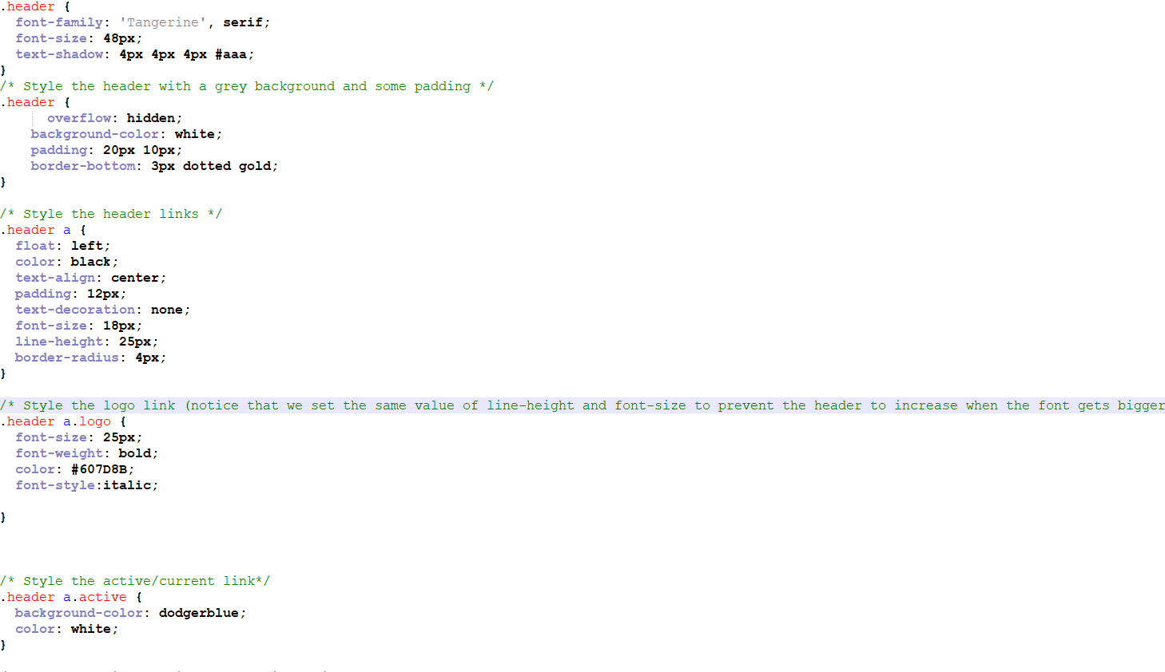

1. CSS Techniques:

There are various techniques used in this website, such as the font is from external source google fonts. I have set our custom colors, fonts, paddings, margins, overflow, borders, and their colors as well as design, font-weights, background colors, and text-alignment etc.

Reference Book: <https://books.google.com.pk/books/about/Pro_CSS_Techniques.html?id=B0iGWa36cOMC&printsec=frontcover&source=kp_read_button&hl=en&redir_esc=y#v=onepage&q&f=false>

1. Graphics and other media

<https://www.fcbarcelona.com/en/>

<https://en.wikipedia.org/wiki/FC_Barcelona_Voleibol>

<https://en.wikipedia.org/wiki/UNES_FC_Barcelona>

<https://www.google.com/search?q=FC+Barcelona+Rugby+League&tbm=isch&ved=2ahUKEwjQ_ZmGsu77AhX5U6QEHTnKBpEQ2-cCegQIABAA&oq=FC+Barcelona+Rugby+League&gs_lcp=CgNpbWcQAzIECCMQJzIFCAAQgAQyBQgAEIAEUKgDWKgDYIkFaABwAHgAgAHgAogB4AKSAQMzLTGYAQCgAQGqAQtnd3Mtd2l6LWltZ8ABAQ&sclient=img&ei=2SKUY5CtK_mnkdUPuZSbiAk&bih=746&biw=1536&rlz=1C1CHBF_enPK1016PK1016>

<https://www.google.com/search?q=CV+Barcelona&tbm=isch&ved=2ahUKEwjlr6vzsu77AhVEiRoKHdJWBeYQ2-cCegQIABAA&oq=CV+Barcelona&gs_lcp=CgNpbWcQAzIECCMQJ1DJBFjJBGCiBmgAcAB4AIAB_wKIAf8CkgEDMy0xmAEAoAEBqgELZ3dzLXdpei1pbWfAAQE&sclient=img&ei=viOUY-XYI8SSatKtlbAO&bih=746&biw=1536&rlz=1C1CHBF_enPK1016PK1016>

<https://www.fcbarcelona.com/en/football/first-team/standings>

<https://www.google.com/maps/place/Barcelona,+Spain/@41.3926679,2.1401891,12z/data=!3m1!4b1!4m5!3m4!1s0x12a49816718e30e5:0x44b0fb3d4f47660a!8m2!3d41.3873974!4d2.168568>

1. Testing (browser, font and screen size, platform including mobile)

Desktop Screen

Google Chrome

Microsoft Edge

# Responsive Media Screens

## 400 Pixels

## 600 Pixels

## 920 Pixels

There is no Copyright permission required, as we’ve used the content which is freely available.